Barn Quilt BVR Rally

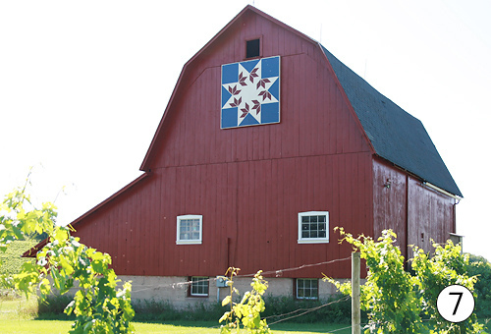

October 22, 2016

9:00 am start time

Starts at 10748 Patterson Rd.

Durand, IL 61024

Ends about noon at FIBS in Brodhead, WI

The Old Opry House on the square

To enter/pre-register email Judy Cunningham at cunninju1@yahoo.com. Include the driver and navigator name.

This will be a fun, check out the fall colors and see some interesting barns rally. There will be possible side stops at an apple orchard, cheese factory, brewery, and Amish stores. The starting point has a barn quilt – look for a checkered flag near the road. Don’t miss this one!!

